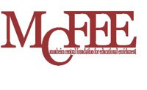
Dinner and Auction
March 28, 2015
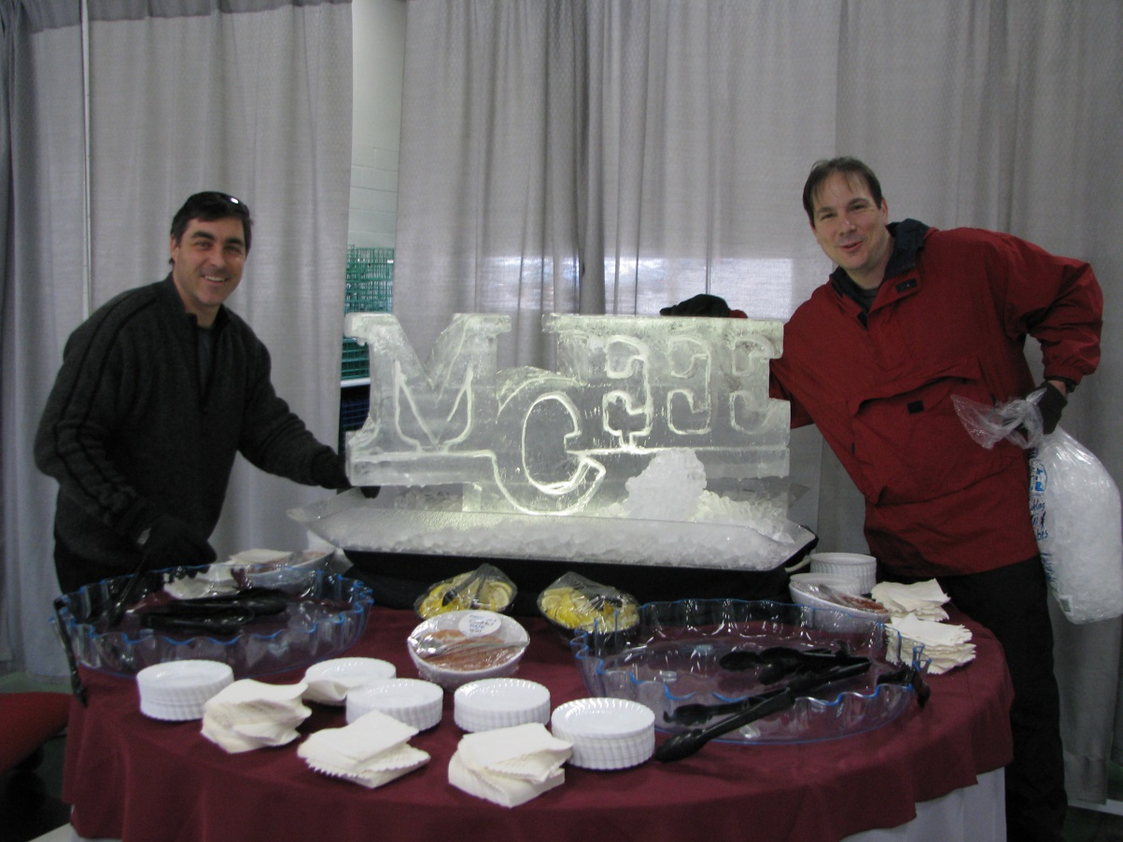
Reserve Your Table for 10 People
$450

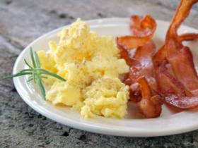
B.R.A.K.E.S
Participants and
Families
You’re invited to the MCFEE Family Breakfast held
at the Manheim Auto Auction
this morning from 7 to 10:30 AM
$7 per person, children 6 and under are free

Great Food for a Great Cause- help us continue to enrich the education of Manheim Central Students!

