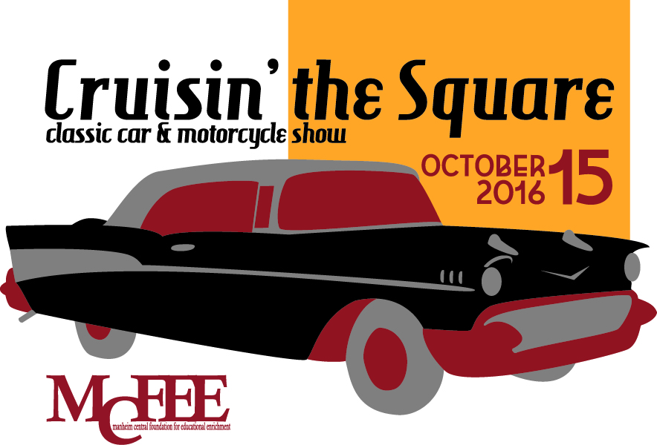
Cruisin’ The Square is back and the Manheim Central Foundation for Educational Enrichment would love for you to be a part of this event!
The Manheim Downtown Development Group has held 15 wonderful years of this classic car and motorcycle show and MCFEE intends to continue the high standards of family entertainment that they have provided for the people of Manheim. There will be child friendly activities, entertainment, food and beautiful cars to see throughout the square and nearby streets. This event will be held on Saturday, October 15, 2016 from 10 until 2, with a rain date of October 22. Vendor set up is 7AM with registration and cars parking at 8AM.
We have the following sponsorship levels and benefits for your business. We appreciate your consideration of being involved this year!
Trophy Sponsor: $150
- You will vote on the car to receive your Stiegel Glassworks handmade trophy.
- Your company description will be featured at the award ceremony.
- The trophy with your company’s name to be awarded to a participant of the show by a representative of your company.
- 2 MCFEE Breakfast Tickets- November 5 at the Manheim Auto Auction
Custom Sponsor: $250
- 1 complimentary vehicle registration entry
- Available to place marketing materials and/or items in the participants’ gift bags
- Plus All Trophy Sponsor benefits
Classic Sponsor: $500
- Up to 4 complimentary vehicle registration entries
- Your business logo on event posters around Lancaster and Lebanon Counties
- Your Banner with company logo and name displayed at the site
- Sponsor may exhibit their business booth at the site
- Plus All Custom and Trophy Sponsor benefits
We are also seeking some door prizes for the car registrants. A great way to promote your business to car lovers.
Thank you so much for your interest in the 2016 Cruisn’ the Square event. Our sponsorship deadline is . We look forward to hearing from you.
Contact Russ and Cheryl Burke at 717-964-1150 for further information.
Yes, we would like to be a sponsor of the 2016 MCFEE Crusin’ The Square :

_____Trophy Sponsor: $150
Name for Trophy __________________________________
_____Custom Sponsor: $250
Name for Trophy _____________________________________
Type of Car to Register _________________________________
Item for Gift Bag _____________________________________
_____ Classic Sponsor: $500
Name for Trophy _____________________________________
Type of Car to Register _________________________________
Second Car to Register __________________________________
Item for Gift Bag _____________________________________
Business Display for the event yes no
Send logo to cburke@mcfee4kids.org

Door Prize for the Car Show Participants: ______________________________
Other Sponsorship: ________________________________________
Name of Business: _____________________________Contact Person:_____________
Address _______________________________________________________
Phone: ________________________________ Email _________________________

Please return this form by ___________________ to
MCFEE
PO Box 475
Manheim, PA 17545

